Manav Rachna International Institute of Research and Studies
ORACLE LAB
Anshita rohilla 22/FCA/BCA(aiml)/039

1. Step 1: Defining tables Students Table
CREATE TABLE Students (
StudentID INT PRIMARY KEY,
FirstName VARCHAR(50),
LastName VARCHAR(50),
Age INT,
Major VARCHAR(50)

Courses table
);
CREATE TABLE Courses (
CourseID INT PRIMARY KEY,
CourseName VARCHAR(100),
Credits INT
);
Enrollments Table (for many-to-many relationship)
CREATE TABLE Enrollments (
EnrollmentID INT PRIMARY KEY,
StudentID INT,
CourseID INT,
Grade CHAR(1),
FOREIGN KEY (StudentID) REFERENCES Students(StudentID),
FOREIGN KEY (CourseID) REFERENCES Courses(CourseID)
);
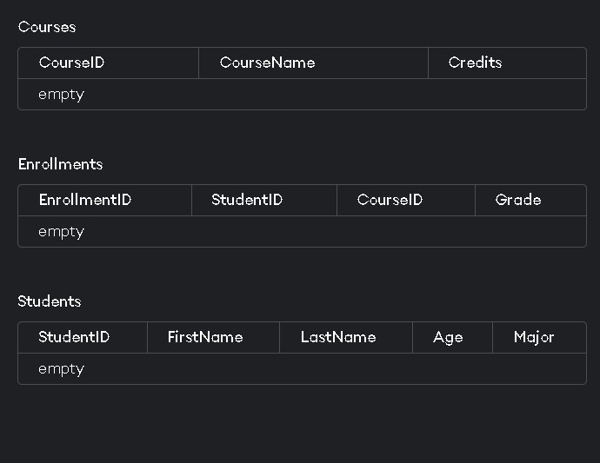

2. Step 2: Inserting Sample Data
Insert Data into Students Table
INSERT INTO Students (StudentID, FirstName, LastName, Age, Major) VALUES
(1, 'John', 'Doe', 20, 'Computer Science'),
(2, 'Jane', 'Smith', 22, 'Mathematics'),
(3, 'Michael', 'Johnson', 21, 'Physics'),
(4, 'Emily', 'Davis', 19, 'Chemistry');
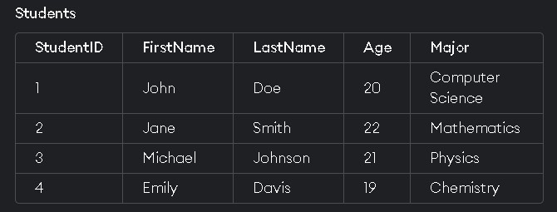
INSERT INTO Courses (CourseID, CourseName, Credits) VALUES
(101, 'Introduction to Programming', 4),
(102, 'Calculus I', 3),
(103, 'General Physics', 4),
(104, 'Organic Chemistry', 4);
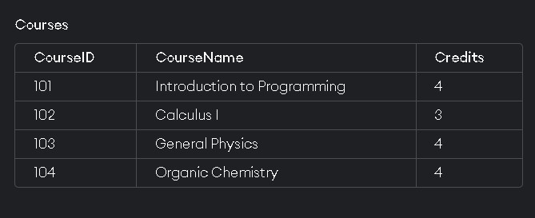
INSERT INTO Enrollments (EnrollmentID, StudentID, CourseID, Grade) VALUES
(1, 1, 101, 'A'),
(2, 1, 102, 'B'),
(3, 2, 103, 'A'),
(4, 3, 101, 'C'),
(5, 4, 104, 'B');
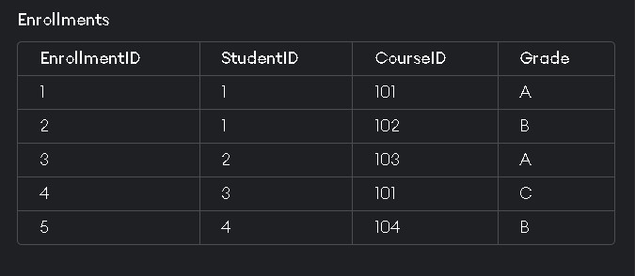

3. Step 3: Queries
- DDL (Data Definition Language) Queries 1. Create Table:
CREATE TABLE Departments (
DepartmentID INT PRIMARY KEY,
DepartmentName VARCHAR(100)
);
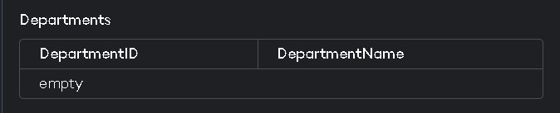
- Alter Table:
ALTER TABLE Students ADD Email VARCHAR(100);
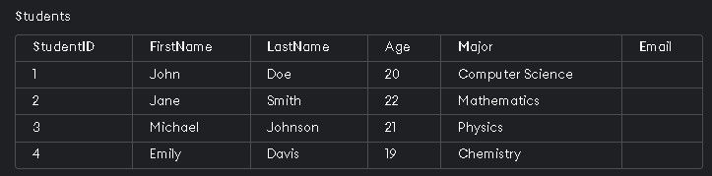
3.Drop Table
DROP TABLE Departments;
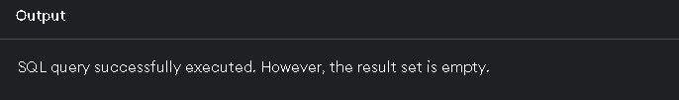

2. DML (Data Manipulation Language) Queries 1. Insert Data
INSERT INTO Students (StudentID, FirstName, LastName, Age, Major, Email) VALUES (5,
'Anna', 'Taylor', 23, 'Biology', 'anna.taylor@example.com');
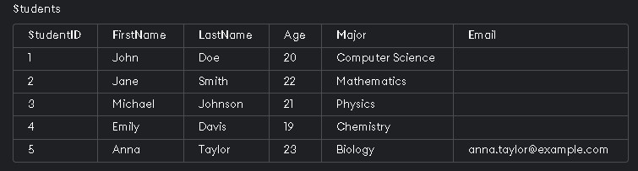

2. Update Data
UPDATE Students SET Major = 'Software Engineering' WHERE StudentID = 1;
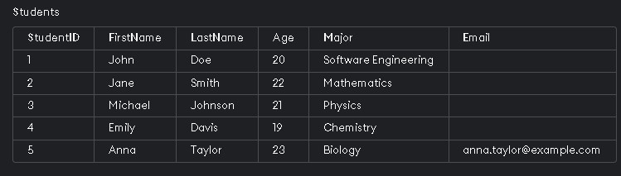

3.Delete Data
Delete FROM Students WHERE StudentID = 4;
-- Deletion anomaly –
Output: Deletes Emily's record from the Students table.

3.DQL (Data Query Language) Queries
- Select Data
SELECT * FROM Students;
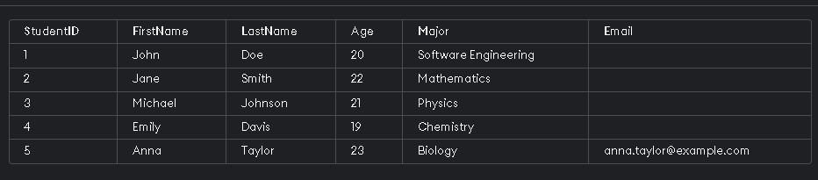
- Where Clause
SELECT * FROM Students WHERE Age > 20;
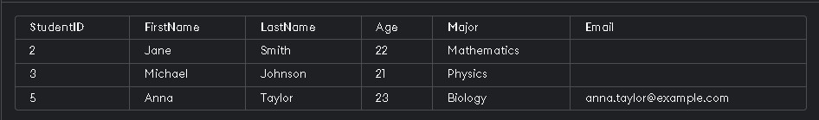
- Order By Clause
SELECT * FROM Students ORDER BY LastName;
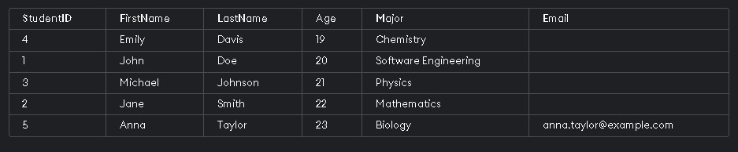

4.Arithmetic Operations
- Select with Arithmetic Operations
SELECT StudentID, FirstName, Age, Age + 1 AS NextYearAge FROM Students;
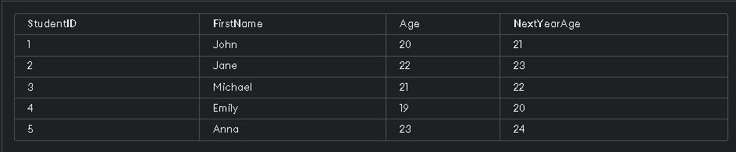
5.Primary and Foreign Key Relationships
1. Create Table with Foreign Key CREATE TABLE Advisors (
AdvisorID INT PRIMARY KEY,
AdvisorName VARCHAR(100),
StudentID INT,
FOREIGN KEY (StudentID) REFERENCES Students(StudentID)
);
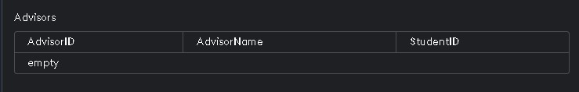
- Insert Data into Table with Foreign Key
INSERT INTO Advisors (AdvisorID, AdvisorName, StudentID) VALUES (1, 'Dr. Smith', 2);
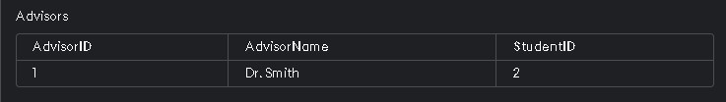

6. Join Operations
- Inner Join
SELECT Students.FirstName, Students.LastName, Courses.CourseName
FROM Students
JOIN Enrollments ON Students.StudentID = Enrollments.StudentID
JOIN Courses ON Enrollments.CourseID = Courses.CourseID;
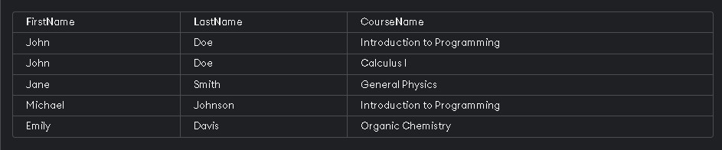

- Left Join
SELECT Students.FirstName, Students.LastName, Enrollments.Grade
FROM Students
LEFT JOIN Enrollments ON Students.StudentID = Enrollments.StudentID;
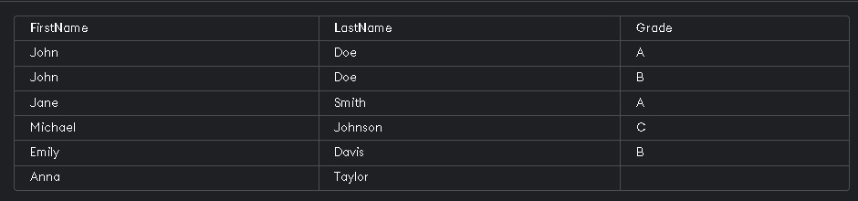
- Right Join
SELECT Students.FirstName, Students.LastName, Enrollments.Grade
FROM Students
RIGHT JOIN Enrollments ON Students.StudentID = Enrollments.StudentID;
Output: Displays all enrollments and the respective student details, if available.

- Step 4: All Queries

1. Create Students Table

CREATE TABLE Students (
StudentID INT PRIMARY KEY,
FirstName VARCHAR(50),
LastName VARCHAR(50),
Age INT,
Major VARCHAR(50)
);
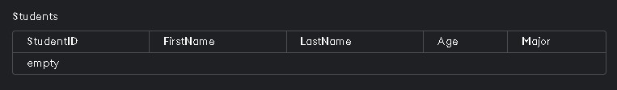
- Create Courses Table CREATE TABLE Courses (
CourseID INT PRIMARY KEY,
CourseName VARCHAR(100),
Credits INT
);

- Create Enrollments Table

CREATE TABLE Enrollments (
EnrollmentID INT PRIMARY KEY,
StudentID INT,
CourseID INT,
Grade CHAR(1),
FOREIGN KEY (StudentID) REFERENCES Students(StudentID),
FOREIGN KEY (CourseID) REFERENCES Courses(CourseID)
);
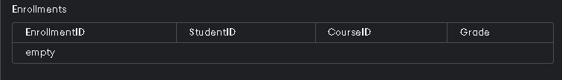
- Insert Data into Students Table

INSERT INTO Students (StudentID, FirstName, LastName, Age, Major) VALUES (1, 'John', 'Doe', 20,
'Computer Science');
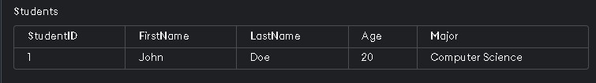
- Insert Data into Courses Table

INSERT INTO Courses (CourseID, CourseName, Credits) VALUES (101, 'Introduction to
Programming', 4);

- Insert Data into Enrollments Table

INSERT INTO Enrollments (EnrollmentID, StudentID, CourseID, Grade) VALUES (1, 1, 101, 'A');
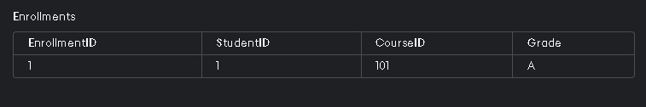
- Select All Students
SELECT * FROM Students;
- Select all Courses
SELECT * FROM Courses;
- Select All Enrollments
SELECT * FROM Enrollments;
- Select Students Older than 19

SELECT * FROM Students WHERE Age > 19;
- Update Student Major
UPDATE Students SET Major = 'Software Engineering' WHERE StudentID = 1;
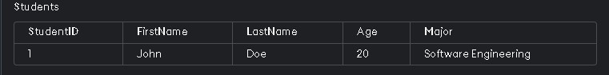
- Delete a Student Record
DELETE FROM Students WHERE StudentID = 4; Output: Emily Davis' record deleted.

- Create Departments Table
CREATE TABLE Departments ( DepartmentID INT PRIMARY KEY,
DepartmentName VARCHAR(100)
);

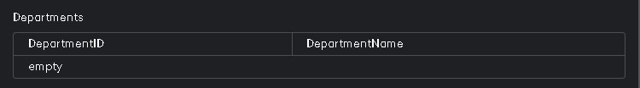
- Add Column to Students Table
ALTER TABLE Students ADD Email VARCHAR(100);
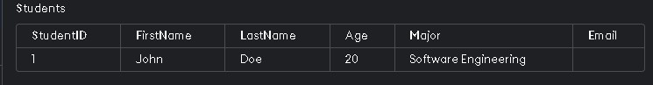
- Drop Departments Table
DROP TABLE Departments;
Output: Departments table dropped.

- Insert New Student with Email
INSERT INTO Students (StudentID, FirstName, LastName, Age, Major, Email) VALUES (5, 'Anna',
'Taylor', 23, 'Biology', 'anna.taylor@example.com');
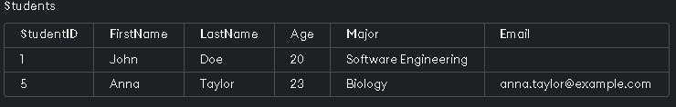
- Select Students with Age Arithmetic Operation
SELECT StudentID, FirstName, Age, Age + 1 AS NextYearAge FROM Students;

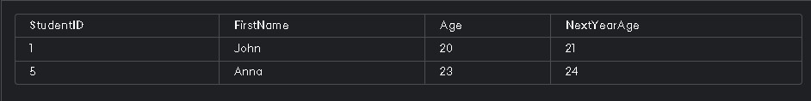

18. Create Advisors Table with Foreign Key

CREATE TABLE Advisors (
AdvisorID INT PRIMARY KEY,
AdvisorName VARCHAR(100),
StudentID INT,
FOREIGN KEY (StudentID) REFERENCES Students(StudentID)
);
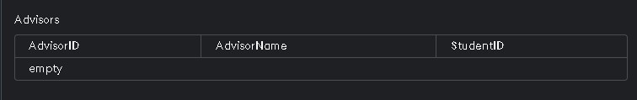

19. Insert Data into Advisors Table

INSERT INTO Advisors (AdvisorID, AdvisorName, StudentID) VALUES (1, 'Dr. Smith', 2);

20. Inner Join Students and Enrollments

SELECT Students.FirstName, Students.LastName, Courses.CourseName
FROM Students
JOIN Enrollments ON Students.StudentID = Enrollments.StudentID
JOIN Courses ON Enrollments.CourseID = Courses.CourseID;

- Left Join Students and Enrollments

SELECT Students.FirstName, Students.LastName, Enrollments.Grade FROM Students
LEFT JOIN Enrollments ON Students.StudentID = Enrollments.StudentID;
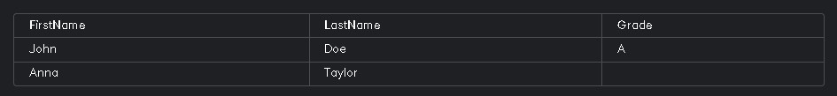

- Right Join Students and Enrollments

SELECT Students.FirstName, Students.LastName, Enrollments.Grade
FROM Students
RIGHT JOIN Enrollments ON Students.StudentID = Enrollments.StudentID;
Output: Displays all enrollments and the respective student details, if available.

- Count Number of Students
SELECT COUNT(*) AS NumberOfStudents FROM Students;

- Select Distinct Majors
SELECT AVG(Age) AS AverageAge FROM Students;
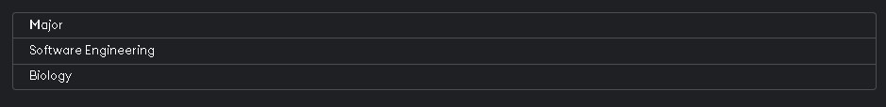

- Select Average Age of Students
SELECT AVG(Age) AS AverageAge FROM Students;
- Select Sum of Credits
SELECT SUM(Credits) AS TotalCredits FROM Courses;
- Select Students Grouped by Major
SELECT Major, COUNT(*) AS NumberOfStudents FROM Students GROUP BY Major;
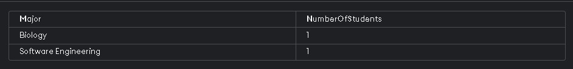
- Select Students with a Specific Major
SELECT * FROM Students WHERE Major = ‘Biology’;

- Select Students with Age Between 20 and 22
SELECT * FROM Students WHERE Age BETWEEN 20 AND 22;
- Select Students with Names Starting with 'J'
SELECT * FROM Students WHERE FirstName LIKE 'J%';

- Select Students in Ascending Order of Age
SELECT * FROM Students ORDER BY Age ASC;
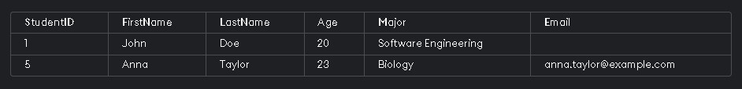
- Select Students in Descending Order of Last Name
SELECT * FROM Students ORDER BY LastName DESC;
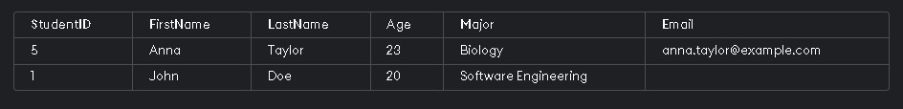
- Select Top 3 Oldest Students
SELECT * FROM Students ORDER BY Age DESC LIMIT 3;

- Update Course Credits
UPDATE Courses SET Credits = 5 WHERE CourseID = 101;

- Delete a Course Record
DELETE FROM Courses WHERE CourseID = 104;
Output: Deletes course with ID 104.

- Select Students Enrolled in a Specific Course SELECT Students.FirstName, Students.LastName
FROM Students
JOIN Enrollments ON Students.StudentID = Enrollments.StudentID
WHERE Enrollments.CourseID = 101;
- Select Courses with More Than 3 Credits
SELECT * FROM Courses WHERE Credits > 3;
- Select Students with Null Email
SELECT * FROM Students WHERE Email IS NULL;
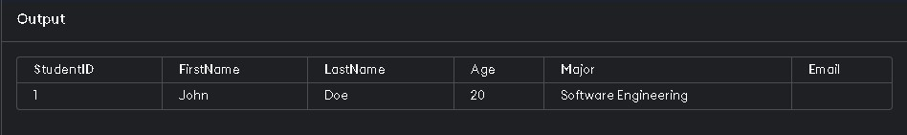
- Select Students with Non-Null Email
SELECT * FROM Students WHERE Email IS NOT NULL;

- Select Students Who Have Taken Multiple Courses
SELECT Students.FirstName, Students.LastName
FROM Students
JOIN Enrollments ON Students.StudentID = Enrollments.StudentID
GROUP BY Students.StudentID, Students.FirstName, Students.LastName
HAVING COUNT(Enrollments.CourseID) > 1;
- Select Enrollments with Grades A or B
SELECT * FROM Enrollments WHERE Grade IN ('A', 'B');
- Select Students with Age Not Between 18 and 22
SELECT * FROM Students WHERE Age NOT BETWEEN 18 AND 22;
- Select Enrollments in Ascending Order of Grade
SELECT * FROM Enrollments ORDER BY Grade ASC;
- Select Course Names and Credits
SELECT CourseName, Credits FROM Courses;
- Select Students Enrolled in Specific Course with Grade A
SELECT Students.FirstName, Students.LastName
FROM Students
JOIN Enrollments ON Students.StudentID = Enrollments.StudentID
WHERE Enrollments.CourseID = 101 AND Enrollments.Grade = 'A';
- Select Students Grouped by Major and Age SELECT Major, Age, COUNT(*) AS NumberOfStudents
FROM Students
GROUP BY Major, Age;
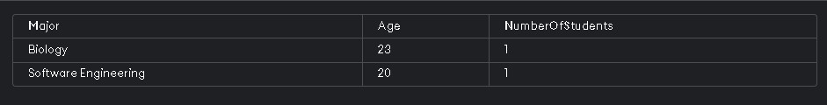
- Select Students and Their Enrollments
SELECT Students.FirstName, Students.LastName, Enrollments.CourseID
FROM Students
JOIN Enrollments ON Students.StudentID = Enrollments.StudentID;
- Select Course Names with Student Count

SELECT Courses.CourseName, COUNT(Enrollments.StudentID) AS StudentCount
FROM Courses
JOIN Enrollments ON Courses.CourseID = Enrollments.CourseID
GROUP BY Courses.CourseName;

- Select Advisors and Their Students

SELECT Advisors.AdvisorName, Students.FirstName, Students.LastName
FROM Advisors
JOIN Students ON Advisors.StudentID = Students.StudentID;
- Select Students Who Haven't Taken Any Courses
SELECT Students.FirstName, Students.LastName
FROM Students
LEFT JOIN Enrollments ON Students.StudentID = Enrollments.StudentID
WHERE Enrollments.StudentID IS NULL;

